Lecture 6



In a conductor, electrons are free to move in the crystal lattice formed by ionic atoms

Electrostatic equilibrium: no motion of electrons

in electrostatic equilibrium:

**1**. The electric field is zero everywhere inside the conductor, whether the conductor is solid or hollow.  
2. If the conductor is isolated and carries a charge, the charge resides on its  
surface.  
3. The electric field at a point just outside a charged conductor is perpendicular to the surface of the conductor and has a magnitude σ/ε0, where σ is the surface charge density at that point.  
4. On an irregularly shaped conductor, the surface charge density is greatest  
at locations where the radius of curvature of the surface is smallest.

We consider a stationary state (no time dependence)

Also, our conductor is a closed system: no electrons come in or out (no batteries attached)

We can create an external electric field using charges outside the conductor

Let’s discuss the 1st property:

The conductor is placed in the external electric field E (Figure 24.16)

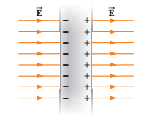 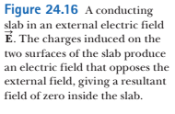

As the external E field is on, electrons start moving to the left ( force eE is applied).

The positive charges are fixed in the crystal lattice. Hence, we will have the situation shown in Figure 24.16 above.

The left surface is negatively charge, the right surface – positively charged

**These planes of charge create an additional electric field inside the conductor that opposes the external field**

This process continues until the additional electric field compensates the external electric field

Net electric field inside the conductor becomes zero

The process is very fast

For a hollow conductor: the electric field inside is zero as well

2*. If the conductor is isolated and carries a charge, the charge resides on its surface.*

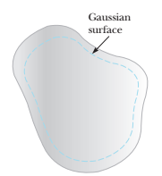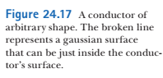

Gauss’s Law:



If E field inside the gaussian surface is zero (the 1st property)

then the net charge inside the gaussian surface is zero

Hence, all net charge of the conductor should reside on the surface

3*. The electric field at a point just outside a charged conductor is perpendicular to the surface of the conductor and has a magnitude σ/ε0, where σ is the surface charge density at that point.*

If the field vector **E** had a component parallel to the conductor’s surface, free electrons would experience an electric force and move along the surface; in such a case, the conductor would not be in equilibrium. Therefore, the field vector must be perpendicular to the surface

To determine the magnitude of the electric field, we use Gauss’s law and draw  
a gaussian surface in the shape of a small cylinder whose end faces are parallel  
to the conductor’s surface (Fig. 24.18)

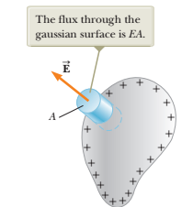 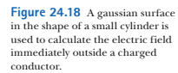

the net flux through the gaussian surface is equal to that through only the flat face outside the conductor, where the field is perpendicular to the gaussian surface.

For the gaussian surface in Figure above (the blue cylinder)

the flux is *EA,* where *E* is the electric field just outside the conductor and *A* is the area of the cylinder’s face. Hence (Gauss’s Law):



qin = σA = the surface charge inside the gaussian surface (the blue cylinder). Hence,



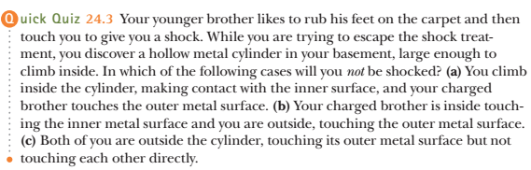



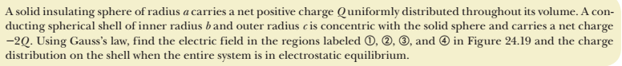

A solid insulating sphere of radius *a* carries a net positive charge *Q* uniformly distributed throughout its volume. A conducting spherical shell of inner radius *b* and outer radius *c* is concentric with the solid sphere and carries a net charge -2*Q* . Using Gauss’s law, find the electric field in the regions labeled 1, 2, 3, and 4 in Figure 24.19 and the charge distribution on the shell when the entire system is in electrostatic equilibrium

Solution:

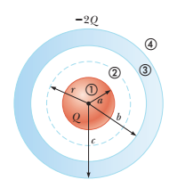 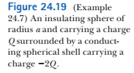

In the region ‘2’ we construct a gaussian surface (blue dash line)

The charge on the conducting shell creates zero electric  
field in the region *r* < *b*, so the shell has no effect on the  
field in region ’2’. Only insulating charged sphere (red) creates an electric field in ‘2’



Shell does not create an electric field inside itself. Hence,

only the insulating sphere (red) will create an electric field

as discussed before:



region 4:

Construct the gaussian surface – a sphere – with radius r > c

the total charge inside: $q_{in}= +Q+ (-2Q)= -Q$

the inernal charge -Q for a spherically symmetric gaussian surface creates the electric field:



In region 3, the electric field must be zero because the  
spherical shell is a conductor in equilibrium:



There are charges in the external and internal surfaces of the shell

What is internal charge?

Construct a gaussian surface inside the shell

since the electric field is zero inside shell, net charge inside the gaussian surface should be zero:

Q + qin = 0, hence qin = -Q

The charge on the external surface of the shell is -2Q – (-Q) = -Q

**Finalize** The charge on the inner surface of the spherical shell must be -*Q* to cancel the charge +*Q* on the solid sphere and give zero electric field in the material of the shell. Because the net charge on the shell is -2Q, its outer surface must carry a charge -*Q .*





**Electric flux** is proportional to the number of electric field lines that penetrate a surface. If the electric field is  
uniform and makes an angle u with the normal to a surface of area *A*, the electric flux through the surface is



In general, the electric flux through a surface is



**Gauss’s law** says that the net electric flux ΦE  
through any closed gaussian surface is equal to the *net*charge *q*in inside the surface divided by ε0



A conductor in **electrostatic equilibrium** has the following properties:  
**1.** The electric field is zero everywhere inside the conductor, whether the conductor is solid or hollow.  
**2.** If the conductor is isolated and carries a charge, the charge  
resides on its surface.  
**3.** The electric field at a point just outside a charged conductor is  
perpendicular to the surface of the conductor and has a magnitude σ/ε0, where σ is the surface charge density at that point.  
**4.** On an irregularly shaped conductor, the surface charge density is  
greatest at locations where the radius of curvature of the surface  
is smallest.

